Task 3.2 D

Introduction
In this task, we will be working with Cirrhosis Patient Survival Prediction dataset that has been provided by UCI. During 1974 to 1984, 424 PBC patients referred to the Mayo Clinic qualified for the randomized placebo-controlled trial testing the drug D-penicillamine. Of these, the initial 312 patients took part in the trial and have mostly comprehensive data. The remaining 112 patients didn't join the clinical trial but agreed to record basic metrics and undergo survival tracking. Six of these patients were soon untraceable after their diagnosis, leaving data for 106 of these individuals in addition to the 312 who were part of the randomized trial.

Dataset
These files contain metadata for all 45,000 movies listed in the Full MovieLens Dataset. The dataset consists of movies released on or before July 2017. This dataset consists of the following files:

FEATURES
- ID: unique identifier
- N_Days: number of days between registration and the earlier of death, transplantation, or study analysis time in July 1986
- Drug: type of drug D-penicillamine or placebo
- Age: age in days
- Sex: M (male) or F (female)
- Ascites: presence of ascites N (No) or Y (Yes)
- Hepatomegaly: presence of hepatomegaly N (No) or Y (Yes)
- Spiders: presence of spiders N (No) or Y (Yes)
- Edema: presence of edema N (no edema and no diuretic therapy for edema), S (edema present without diuretics, or edema resolved by diuretics), or Y (edema despite diuretic therapy)
- Bilirubin: serum bilirubin in mg/dl
- Cholesterol: serum cholesterol in mg/dl
- Albumin: albumin in gm/dl
- Copper: urine copper in ug/day
- Alk_Phos: alkaline phosphatase in U/liter
- SGOT: SGOT in U/ml
- Tryglicerides: tryglicerides data
- Platelets: platelets per cubic in ml/1000
- Prothrombin: prothrombin time in s
- Stage: histologic stage of disease (1, 2, 3, or 4)

TARGET
- Status -> status of the patient C (censored), CL (censored due to liver tx), or D (death)
Cirrhosis dataset output:
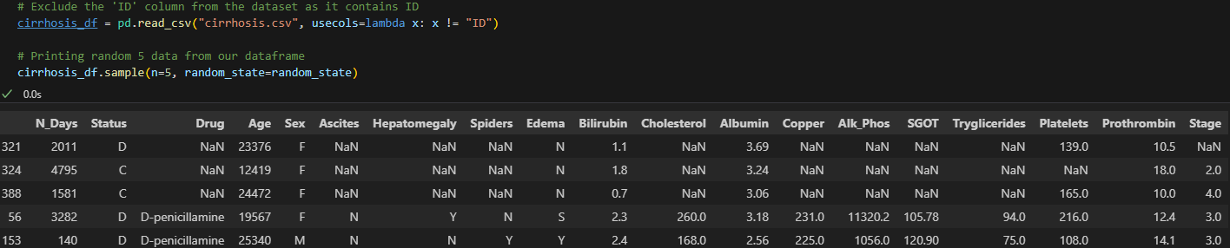

Data Preprocessing

Handling missing values
- Checking for missing values in Cirrhosis database
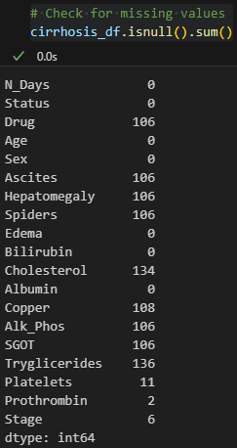

- Imputing missing values using “SimpleImputer” (from sklearn.impute package) with strategy as ‘median’ for numerical features and ‘mode’ for categorical features.
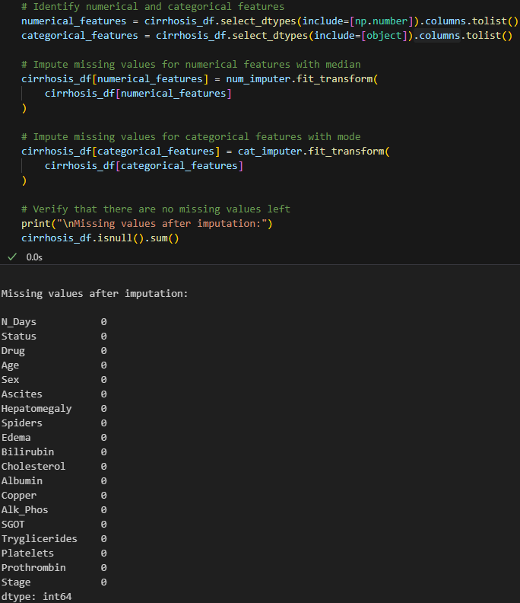

Data Splitting
Using “train_test_split” (from sklearn.model_selection package), splitting the data into training and test sets with an 80:20 ratio ensures a sufficient amount of data for both training and evaluating the model.
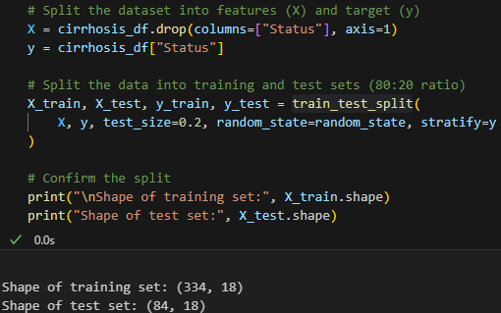

Feature Types
Checking different features for its type, i.e. continuous features and categorical features.
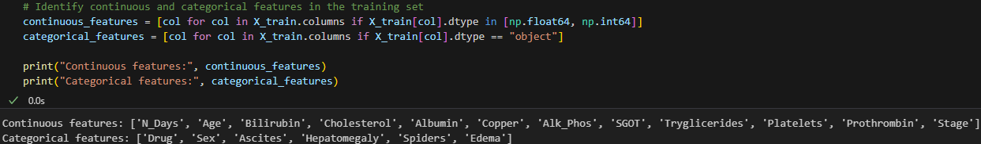

Encoding Categorical Features and Scaling dataset
For encoding and scaling the whole dataset have used the concept of “Pipeline” (from sklearn.pipeline package). In provided dataset we will be using ordinal encoding for ‘Edema’ as its values are in ordered way as (‘N’, ‘S’ and ‘Y’). So using pipeline will be doing all processes of “OneHotEncoder”, “OrdinalEncoder” and “StandardScaler”.
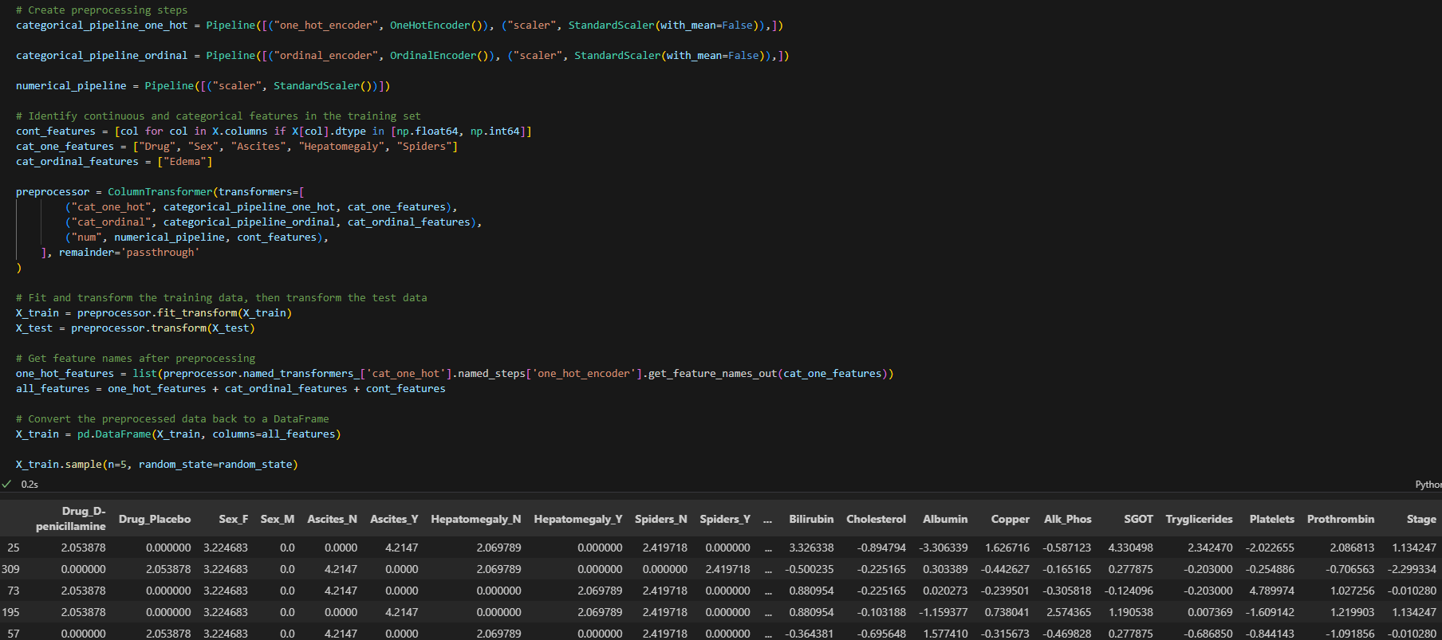

Encoding Target
Using “LabelEncoder”, encoding target variables for further anaylsis.

Target Label Distribution
Checking the label distribution helps to understand whether the dataset is balanced or imbalance.
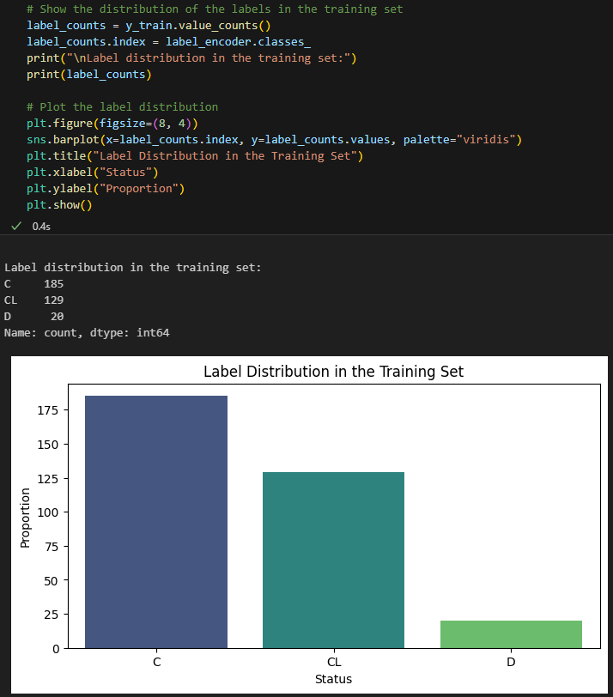

As from above visualization we know that dataset is imbalance with target as ‘D’ value.

SMOTE for Upsampling
Using “SMOTE” to perform over-sampling of data that will be used in out further analysis.
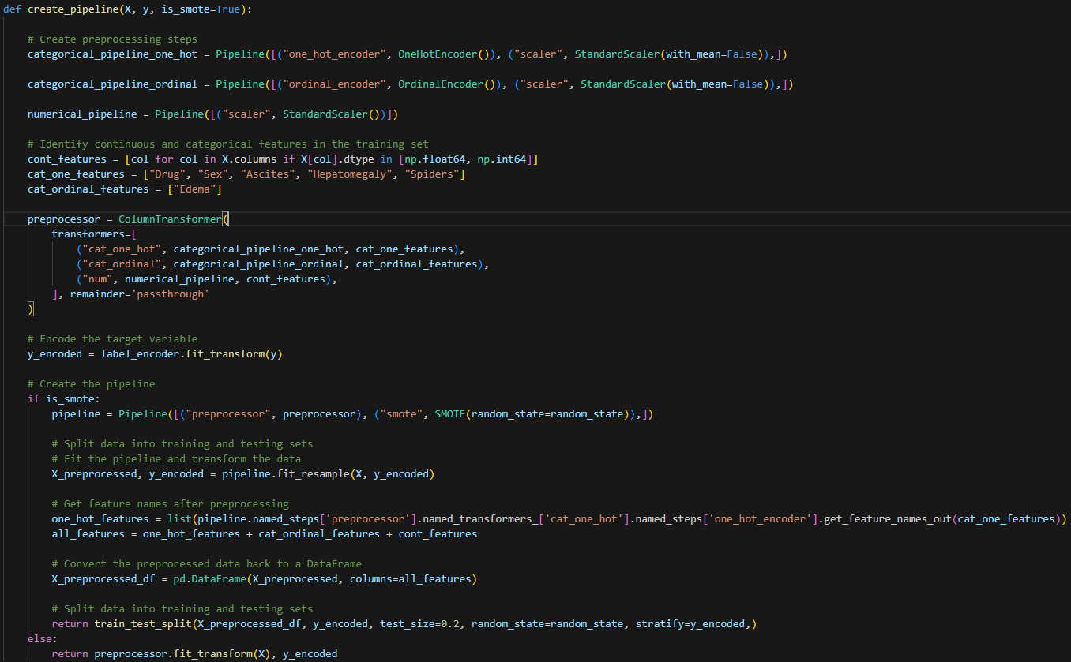

Model Creation and Evaluation

Model to be used
We will be using 3 different supervised machine learning models in our whole analysis:
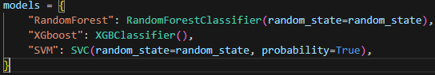

Hyperparameter Optimization
These hyperparams will be used via different models while using GridSearchCV and RandomisedSearchCV.
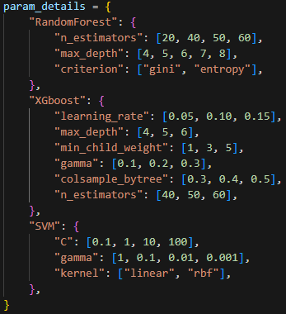
The given ‘param_details’ dictionary outlines the hyperparameters that we might optimize for each model and the reasons for their choices.
- Model RandomForest
  - n_estimators: This parameter specifies the number of trees in the forest. As more trees generally improve performance but also increase computational cost.
  - max_depth: This parameter sets the maximum depth of the tree. As controls overfitting, deeper trees can learn more complex patterns but may overfit.
  - criterion: This parameter determines the function to measure the quality of a split. Different criteria (e.g., Gini impurity, entropy) can affect the splits and ultimately the performance.
- Model XGBoost
  - learning_rate: This parameter controls the step size at each iteration while moving toward a minimum of the loss function. Balances between converging too quickly (risk of missing the optimal point) and too slowly.
  - max_depth: Similar to RandomForest, it sets the maximum depth of a tree. Controls the complexity of the model.
  - min_child_weight: This parameter defines the minimum sum of instance weight (hessian) needed in a child. Used to control overfitting.
  - gamma: This parameter specifies the minimum loss reduction required to make a further partition on a leaf node of the tree. Controls whether a given node will split further based on the reduction in the loss function.
  - colsample_bytree: This parameter denotes the fraction of features to be randomly sampled for each tree. Controls overfitting by sampling a subset of features for each tree.
  - n_estimators: The number of boosting rounds. More boosting rounds can lead to better performance but also increased computational cost and risk of overfitting.
- Model SVM
  - C: This parameter controls the regularization strength. Affects the margin width; a high C aims for a low bias and high variance, while a low C does the opposite.
  - gamma: This parameter defines how far the influence of a single training example reaches. Affects the decision boundary; high gamma can lead to overfitting.
  - kernel: This parameter specifies the kernel type to be used in the algorithm. Different kernels (e.g., linear, RBF) can capture different patterns in the data.

Model Creation
Model creation and evaluation has been done with above defined models and metrics that has been used are ‘accuracy_score’, ‘roc_auc_score’, ‘precision_score’, ‘recall_score’ and ‘f1_score’.
Model creation will be divided into 3 parts:
- Model checkpoint-1
In this part, we will be using the dataset that has been pre-processed with original dataset.
- Simple models training:
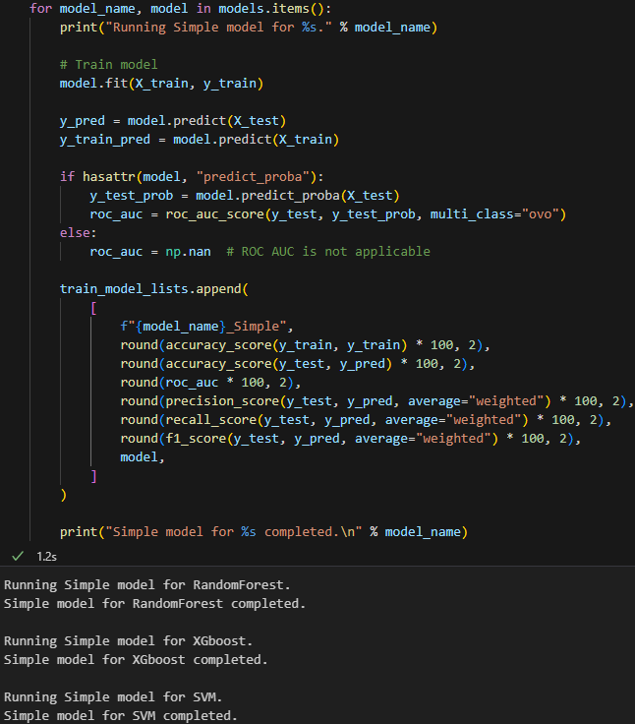
- GridSearchCV simple models training:
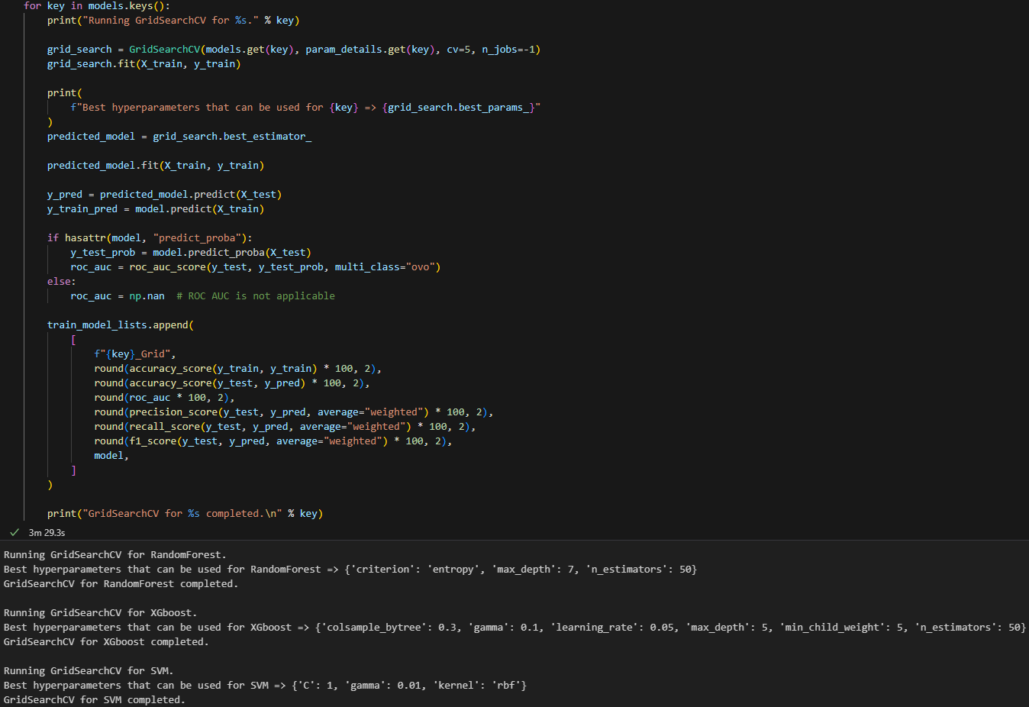

- RandomizedSearchCV simple models training:
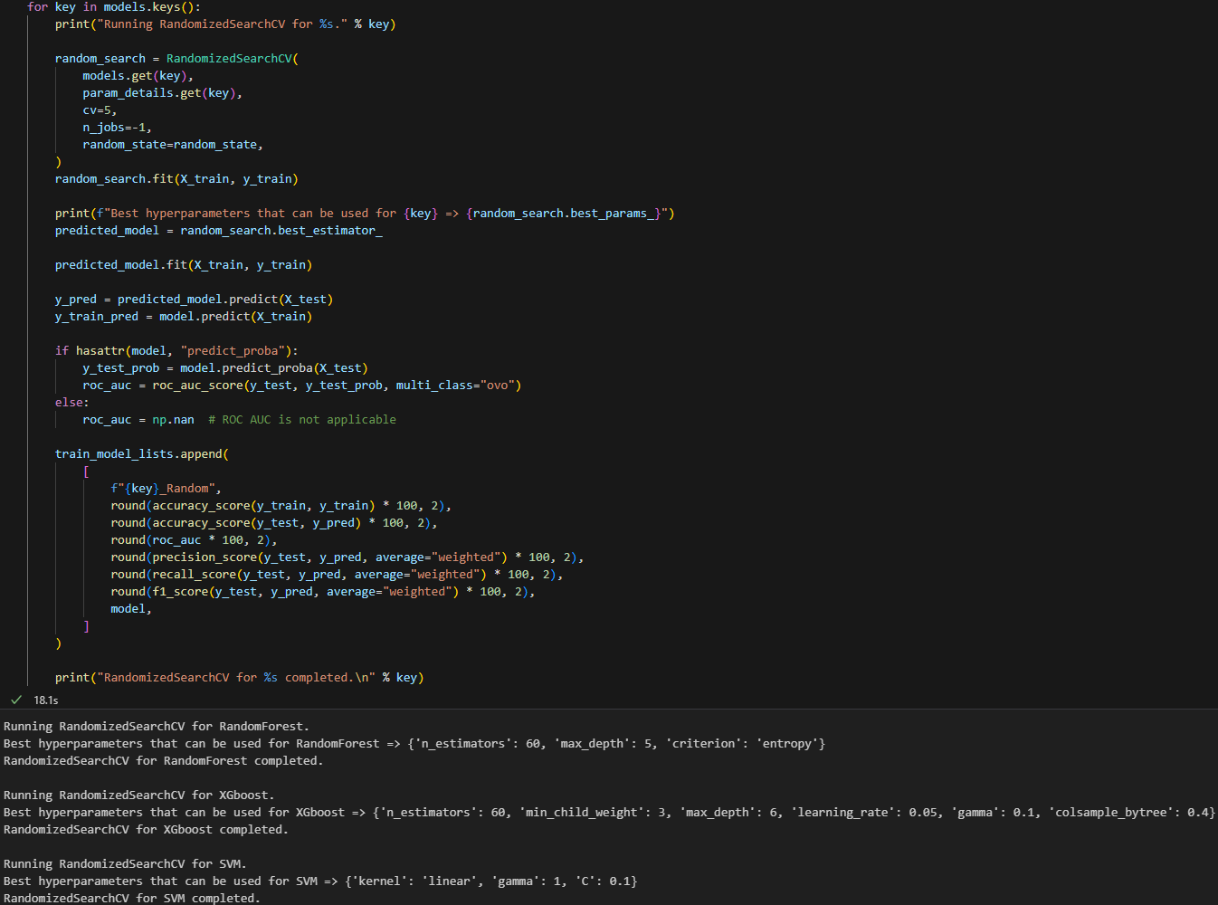

- Model checkpoint-2
In this part, we will be using the dataset that has been pre-processed with Upsampling dataset via SMOTE.
- SMOTE simple models training:
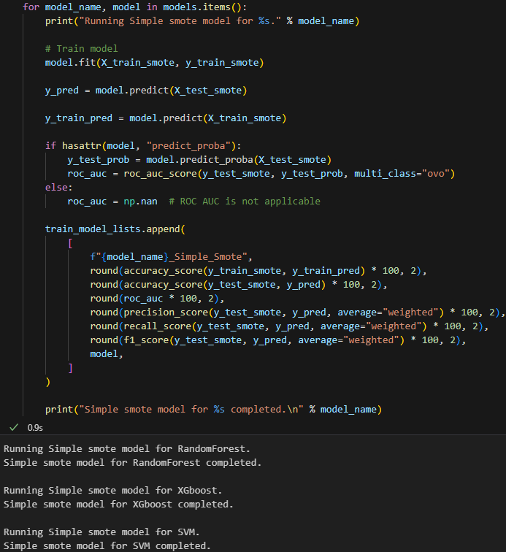

- GridSearchCV SMOTE simple models training:
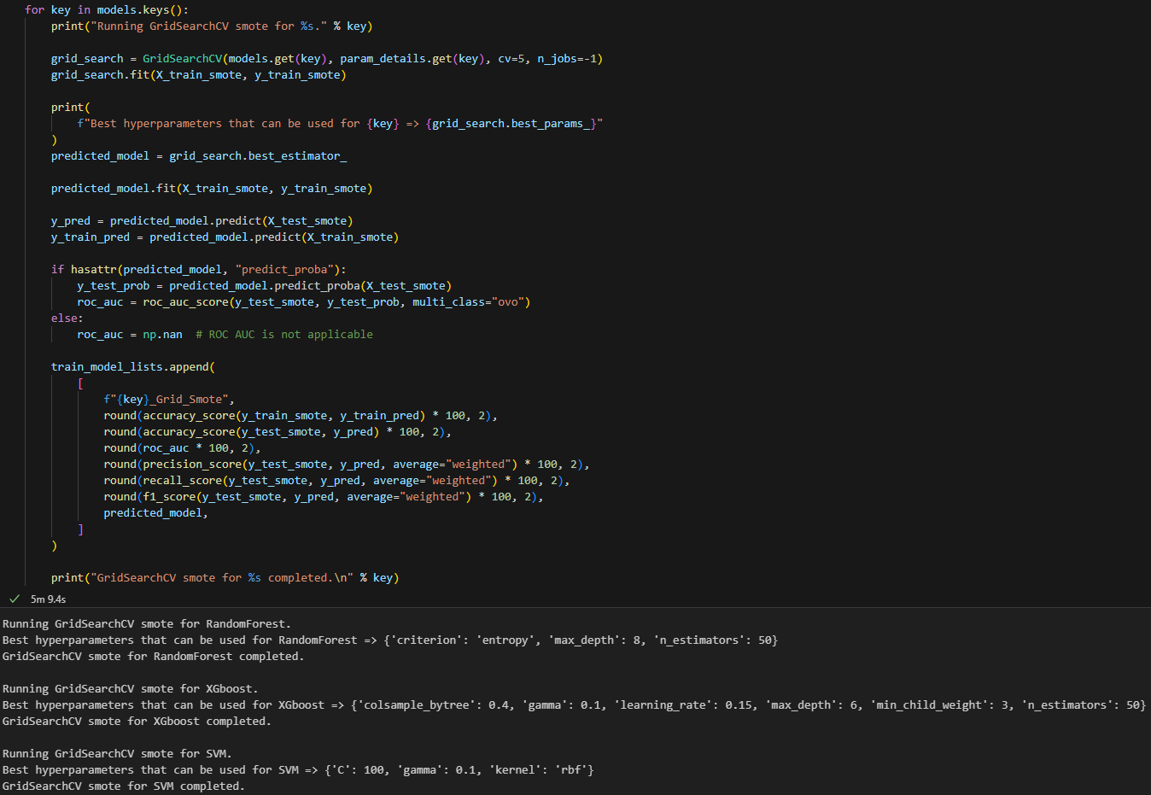
- RandomizedSearchCV SMOTE simple models training:
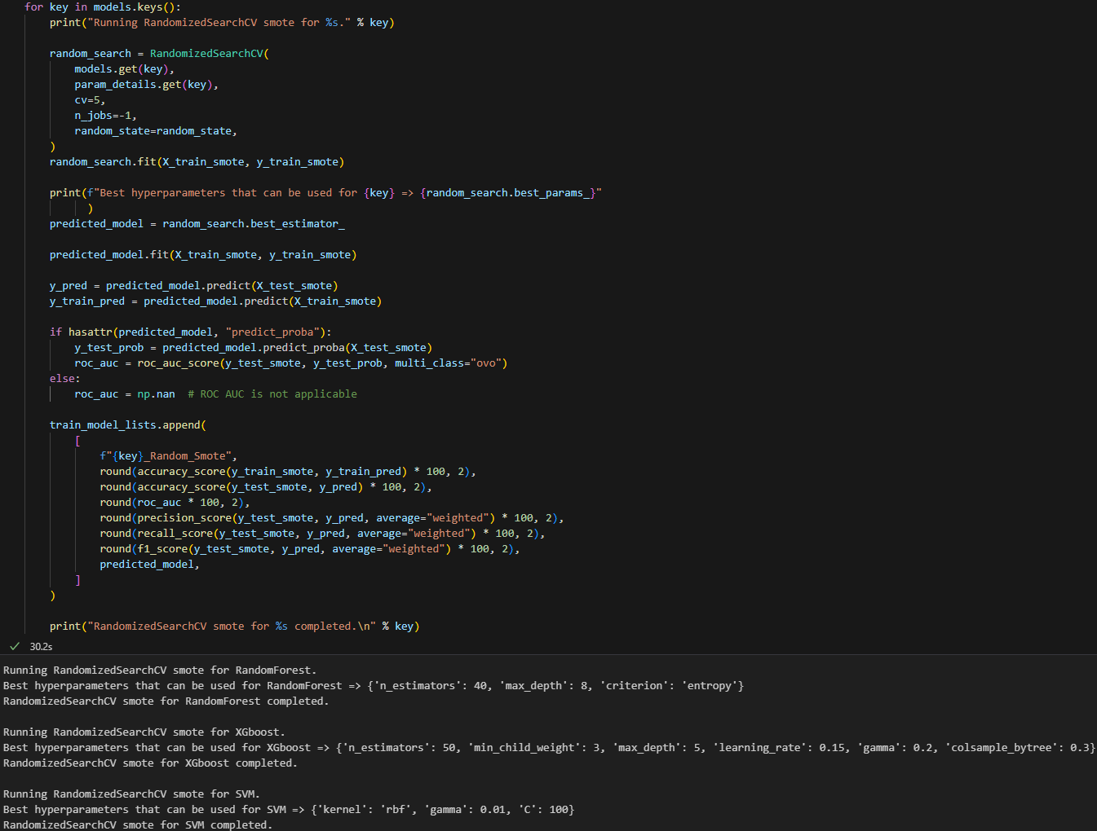

- Model checkpoint-3
In this part we will be training simple model using “StratifiedKFold” cross-validator.
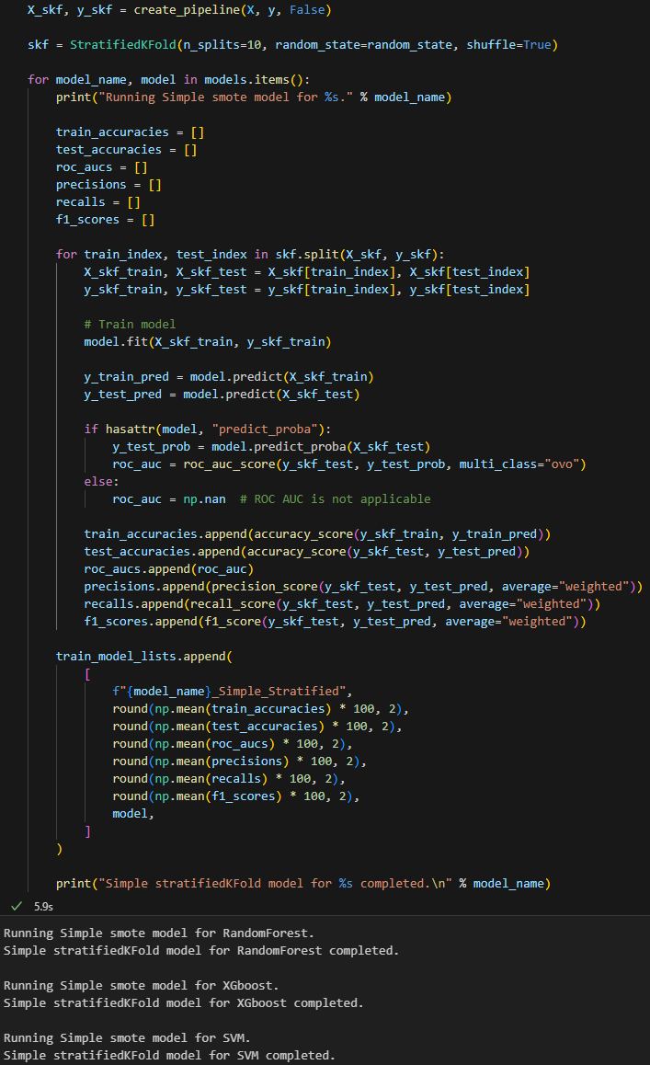

Model Evaluation
As we have taken our models into lists where all metrics has been noted, so will be comparing models on different metrics. Listing all models which were trained while our analysis:
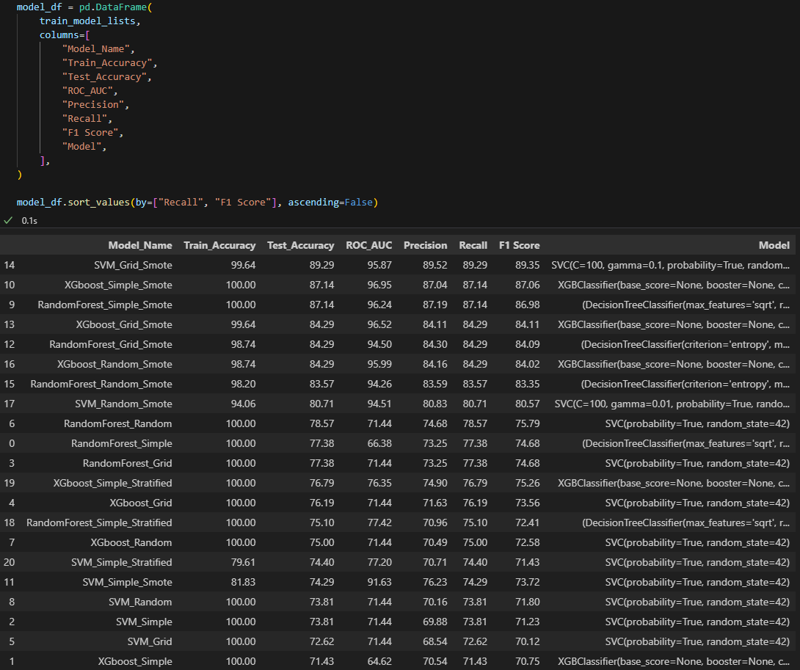

From the above list of different models, will be using `SVM_Grid_Smote` model, reason:
- `RandomForest_Simple_Smote`, `XGboost_Simple_Smote` and `XGboost_Grid_Smote` models have almost 100% train_accuracy which can say it’s mostly overfitting the model as test_accuracy is low.
As checking `recall` and `f1 score` as metrics to get the best model, so on the basis of all checks, will be taking `SVM_Grid_Smote` as further analysis model.

Best Model Prediction
As from the above we have taken the best model as `SVM_Grid_Smote`, so will be providing different metrics for the model.
- Code used for providing details:
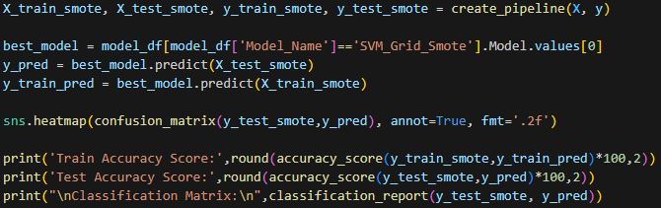

- Classification Matrix:
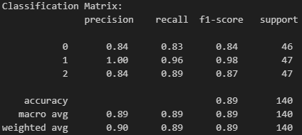

- Confusion Matrix in heatMap:
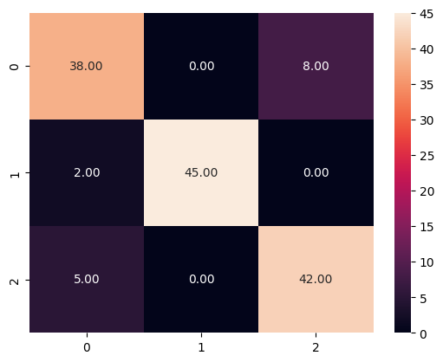

Feature Importance
We will using more than 2 different feature importance technique to visualize and understand what further we can improve in our analysis to make our model more much better and can be used for real time classification over different new test datasets.

Random Forest Feature Importance
It is calculated based on the mean decrease in impurity (Gini importance or Mean Decrease Impurity). It measures how much each feature contributes to decreasing the impurity in the decision trees that constitute the Random Forest. A higher importance score indicates that the feature is more critical for the model's predictions.
Coding:
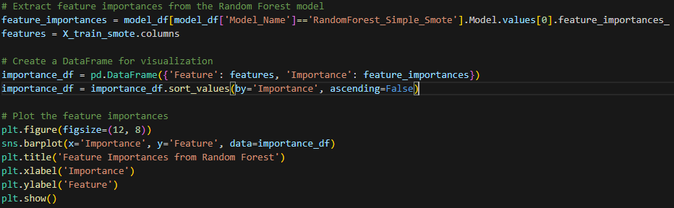
Graphical Representation:
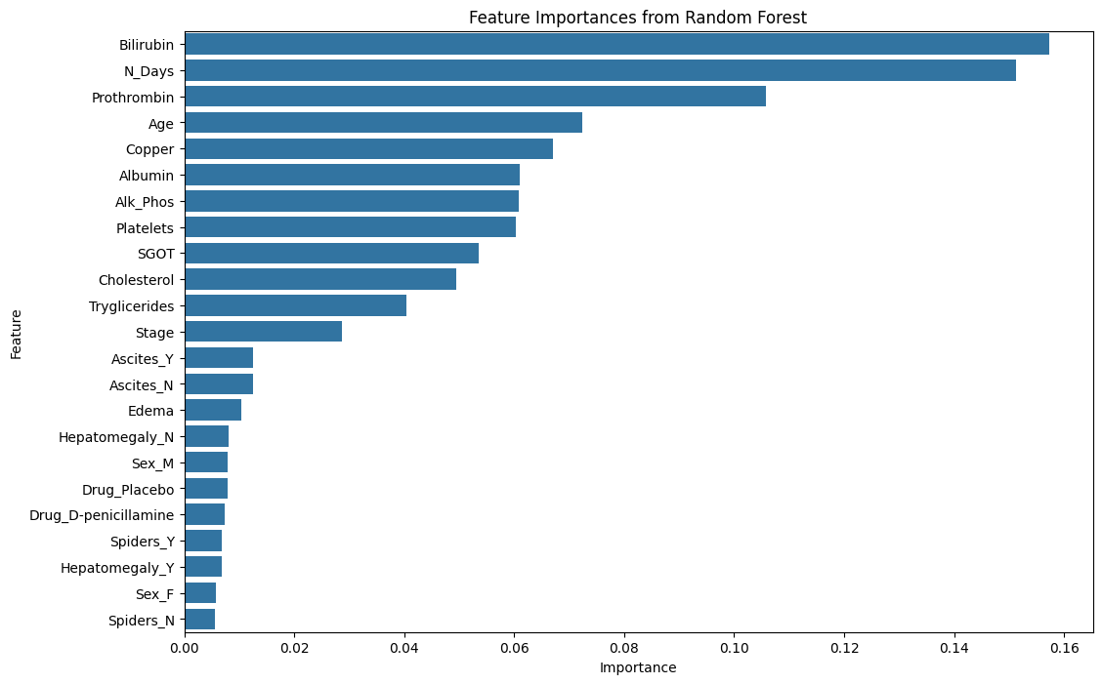

Analysis of Random Forest feature importance:
- Features like `Bilirubin`, `N_Days`, and `Prothrombin` are statistically significant predictors. Their high importance scores indicate that these features are critical for reducing impurity in the decision trees, leading to better model performance.
- Features with moderate importance scores contribute to the model but are not as critical as the top predictors. They still provide valuable information but are secondary to the high importance features.
- Features with low importance scores have minimal impact on the model's performance. Statistically, this means that the model's predictions are less sensitive to changes in these features lie `Spiders_N`, `Sex_f` and more.

Permutation Feature Importance
It measures the impact of each feature on the model's predictive performance by shuffling the values of the feature and observing the decrease in performance. If shuffling a feature's values leads to a significant drop in model performance, it indicates that the feature is important.
Coding:
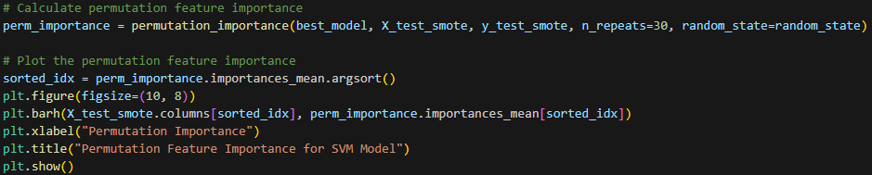
Graphical Representation:
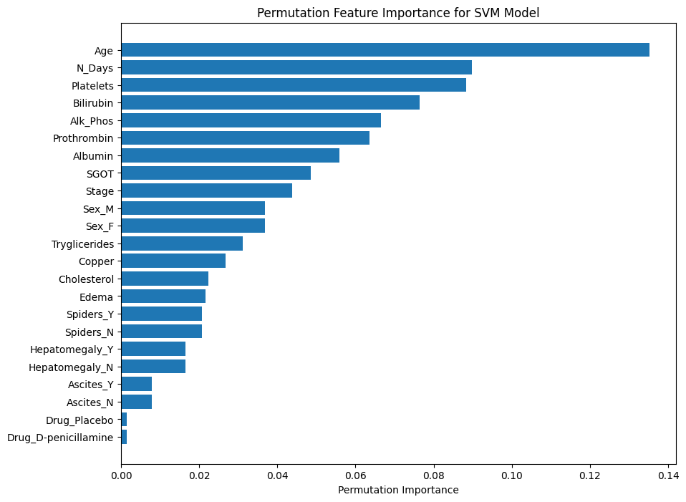
Analysis of Permutation Feature Importance:
- Features like `Age`, `N_Days`, and `Platelets` are statistically significant predictors in the model. Their high permutation importance indicates that changes in these features lead to substantial changes in the model's predictions.
- Features with moderate importance contribute to the model but have less influence compared to the top predictors. These features still provide valuable information but are not as critical.
- Features with low permutation importance have minimal impact on the model's performance. Statistically, this means that the model's predictions are less sensitive to changes in these features, like `Drug_Placebo`, `Drug_D-penicillamine` and more.

Correlation Matrix Feature Importance
It is a statistical technique that uses a table of correlation coefficients to evaluate the relationship between two or more variables in a data set. The correlation coefficients range from -1 to +1, where -1 indicates a perfect negative correlation, +1 indicates a perfect positive correlation, and 0 indicates no correlation. The matrix can also show the direction of the relationship, whether it's positive or negative.
Coding:
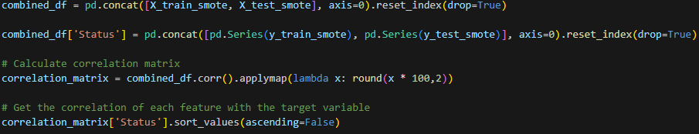
Tabular Representation with “Status” target column:
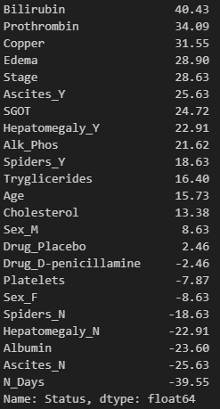
Analysis of Correlation Matrix:
- Features with high positive correlations, such as `bilirubin`, `prothrombin`, and `copper`, are significant predictors of the target condition. These features are likely to increase as the likelihood of the target condition increases.
- Features with low positive correlations, such as `age` and `cholesterol`, have a smaller but still notable impact on the likelihood of the target condition.
- Features with negative correlations, such as `platelets` and `albumin`, are inversely related to the target condition. This means that as these features increase, the likelihood of the target condition decreases.

Summary
We can do more deep dive for our best model predictions, as we can see, our current model can also tends to overfitting side as its train_accuracy is also bit high. So choosing different best model we can perform different pre-processing, feature elimination, dimension-reduction and use more different type of models not only related to supervised learning but can use unsupervised or deep learning models also.

References
Great Learning, n.d. Ensemble Techniques. [Online]
Available at: https://olympus.mygreatlearning.com/courses/78809
Great Learning, n.d. Featurization, Model Selection & Tuning. [Online]
Available at: https://olympus.mygreatlearning.com/courses/78811
Great Learning, n.d. SIG720 - Machine Learning Content. [Online]
Available at: https://olympus.mygreatlearning.com/courses/103484?module_id=818808
Great Learning, n.d. Supervised Learning. [Online]
Available at: https://olympus.mygreatlearning.com/courses/78808
Medium, n.d. Supervised Learning. [Online]
Available at: https://medium.com/@jorgesleonel/supervised-learning-c16823b00c13
scikit-learn, n.d. API Reference. [Online]
Available at: https://scikit-learn.org/stable/api/

